GIT LINUX COMMANDS

**To clone the repository from github to our local**

*Open command task and navigate to desired folder to clone the repository*

git clone <url from git repository>

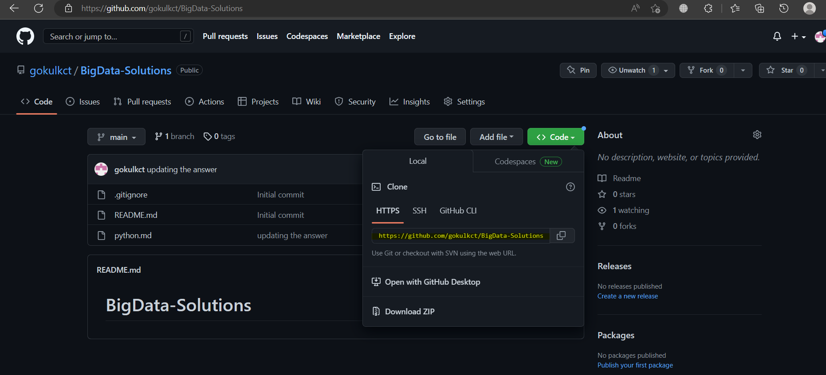

git status = to check the stauts of the code in VS

git add . = to add the code in git repository

git commit -m “<message>” = make the change commit

git push = push the change to git hub repository

***To add the folder***

git init

git add .

git remote add origin <url from repository>

git push origin main

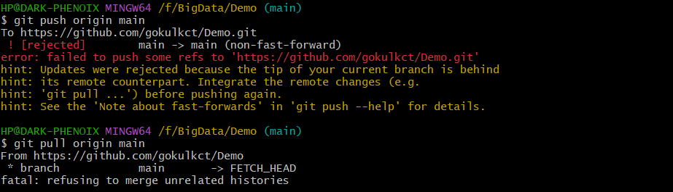

git pull origin main --allow-unrelated-histories

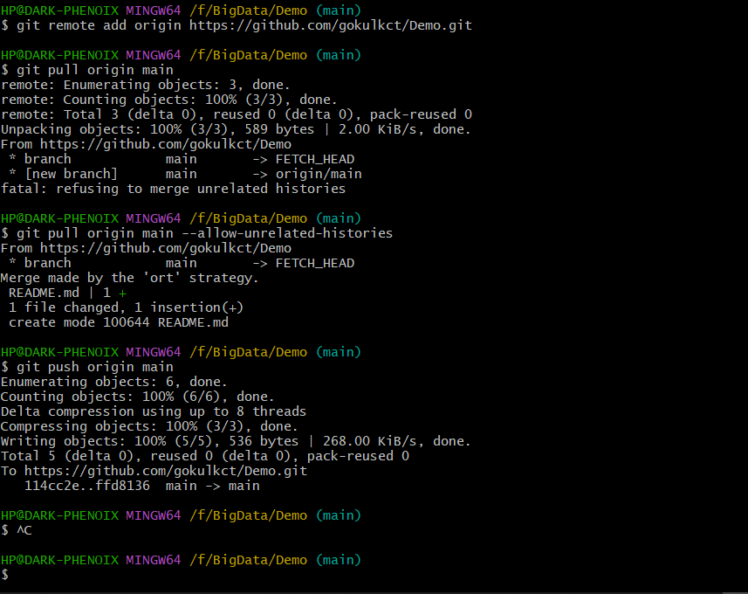

***After updating the document, use the below commands***

git add .

git commit -m “<msg>”

git push origin <main or master>

***To remove connection from github***

rm -rf .git

***Branches***

git branch <branch_name> = creating branch

git checkout <branch_name> = to checkout the branch or to reflect in github. This command will switch from main to new branch

git branch --list = list the branches in repository